Creating a package
- Go to the catkin_ws in your WebShell. In order to do this, type:
  - $ roscd
  - $ cd ..
  - $ cd src
  - $ pwd
- You must end up here in the /home/{user}/catkin_ws/src If directory is wrong try $ source ~/catkin_ws/devel/setup.bash
- The src folder will contain all the packages created. Every time you want to create a new package, you have to be in this directory (catkin_ws/src).
- To create a package.
  - $ catkin_create_pkg {my_package} rospy
  - Example:
    - $ catkin_create_pkg my_sumit_xl_tools rospy
    - $ catkin_create_pkg test_imu rospy
    - $ catkin_create_pkg lawn_tractor_navigation rospy
- In order to check that our package has been created successfully, we can use some ROS commands related to packages. For example, let's type:
  - $ rospack list
  - $ rospack list | grep {my_package}
  - $ roscd {my_package}
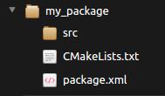
  - Create in the src directory in my_package a Python file that will be executed. For this exercise, just copy this simple python code simple.py. You can create it directly by RIGHT clicking on the IDE on the src directory of your package, selecting New File, and writing the name of the file on the box that will appear.
  - A new Tab should have appeared on the IDE with empty content. Then, copy the content of simple.py into the new file. Finally, press Ctrl-S to save your file with the changes. The Tab in the IDE will go from Green to no color (see pictures below).
Here is the sample code:
#! /usr/bin/env python

import rospy

rospy.init_node("ObiWan")
rate = rospy.Rate(2) # We create a Rate object of 2Hz
while not rospy.is_shutdown(): # Endless loop until Ctrl + C
print "Help me Obi-Wan Kenobi, you're my only hope"
rate.sleep() # We sleep the needed time to maintain the Rate fixed above

# This program creates an endless loop that repeats itself 2 times per second (2Hz) until somebody presses Ctrl + C
# in the Shell

Creating a launch file

- Create a launch directory inside the package named my_package:
    - $ roscd my_package # switch to the “my_pakage” directory
    - $ mkdir launch # create the directory “launch”
- Create a new launch file inside the launch directory. If using the on-line editor you can right click the directory and select New File.
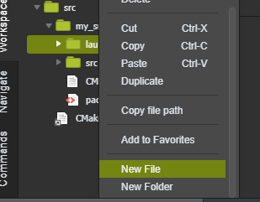

- : touch launch/my_package_launch_file.launch
    - The launch file should look like this:
<launch>
<!-- My Package launch file -->
<node pkg="my_package" type="simple.py" name="ObiWan" output="screen">

Compiling a package
When you create a package, you will need to compile it in order to make it work. The command used by ROS to compile is:
- $ roscd; cd .. or cd ~/catkin_ws/
- $ catkin_make
This command will compile your whole src directory, and it needs to be issued in your catkin_ws directory in order to work. This is MANDATORY. If you try to compile from another directory, it won't work.

Launching a package

Launch your program again using the roslaunch command:
roslaunch my_package my_package_launch_file.launch | Example 1
roslaunch test1_package test1_launch.launch | Example 2
roslaunch read_odometry read_odom_launch.launch | Example 3
roslaunch read_odometry pub_age.launch | Example 4
roslaunch topics_mini_project mini_project.launch  cd src/topics_mini_project/src  ls -la  chmod +x mini_project.py | Example 4

Common Issues
Permissions
It is a common issue when working with Python scripts in this Course, that users get an error similar to this one:
This error usually appears to users when they create a Python script from the WebShell. It happens because when created from the shell, the Python scripts don't have execution permissions. You can check the permissions of a file using the following command, inside the directory where the file is located using: ls -la
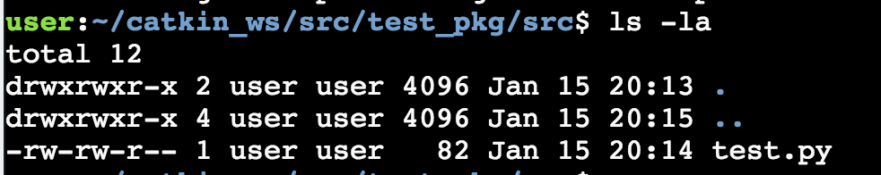 | Example 1
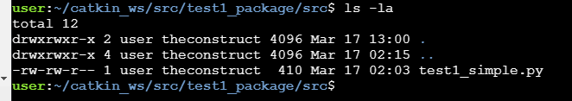 | Example 2

The first row in the left indicates the permissions of this file. In this case, we have -rw-rw-r-. So, you only have read(r) and write(w) permissions on this file, but not execution permissions (which are represented with an x). To add execution permissions to a file, you can use the command: chmod +x name_of_file.py

Source Bash:
You have to run a source command for the bash file

Reading a new topic
Data for Exercice 2.2

- The odometry of the robot is published by the robot into the /odom topic.
- You will need to figure out what message uses the /odom topic, and how the structure of this message is.
For example, On your webshell, type rostopic list and check for a topic named '/counter'.
$ rostopic list | grep '/counter'
Here, you have just listed all of the topics running right now and filtered with the grep command the ones that contain the word /counter. If it appears, then the topic is running as it should.
You can request information about a topic by doing rostopic info <name_of_topic>.
Now, type rostopic info /counter.

So for odom, it would be: $ rostopic info /odom

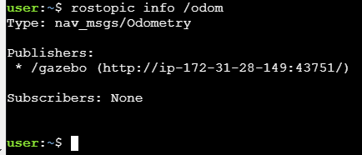 | The output indicates the type of information published (nav_msgs/Odometry), the node that is publishing this information (/gazebo), and if there is a node listening to that info (None in this case).

Messages are defined in .msg files, which are located inside a msg directory of a package.
To get information about a message, you use the command: $ rosmsg show nav_msgs/Odometry
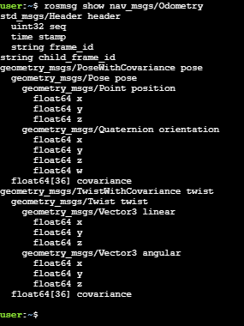 | from nav_msgs.msg import Odometry  pub = rospy.Subscriber('/odom', Odometry, callback)  def callback(msg):  print msg # Print the value 'data' inside the 'msg' parameter  #print msg.header #This will print the header section  #print msg.pose #This will print the pose section
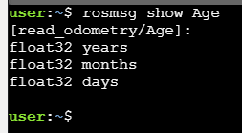 | from read_odometry.msg import Age  pub = rospy.Publisher('/age_info', Age, queue_size=1)  age = Age()  age.years = 5  age.months = 10  age.days = 21  pub.publish(age)

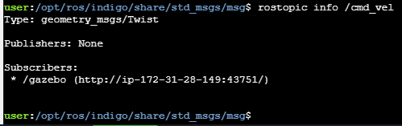
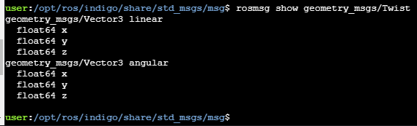
Example commands:
from geometry_msgs.msg import Twist
pub = rospy.Publisher('/cmd_vel', Twist, queue_size=1)
move = Twist()
move.linear.x = 0.5 #Move the robot with a linear velocity in the x axis
move.angular.z = 0.9 #Move the with an angular velocity in the z axis

Creating a new message type

How to make a new message type
https://i-0a32977f89b51beb5.robotigniteacademy.com/jupyter/notebooks/unit2_topics_part2.ipynb#custom_topic_compilation
video explanation: https://www.youtube.com/watch?time_continue=1071&v=GxpS18INc9s
(start at c15:00)
roscd
cd ..
catkin_make
source devel/setup.bash
rosmsg list | grep Age

